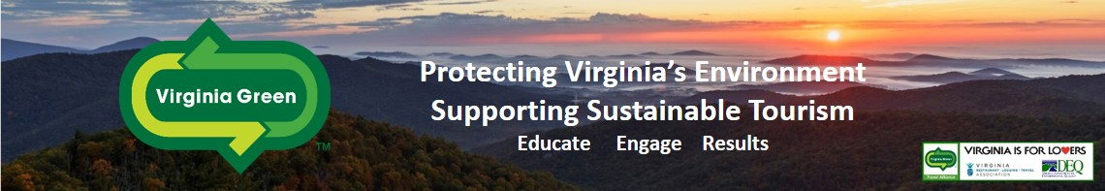
The
Virginia Green Travel Chapters Program
Virginia Green

2022 CHECKLIST FOR VIRGINIA GREEN TRAVEL CHAPTERS
- Virginia Green program will provide an annual update on how many certified Virginia Green partners are in your region / locality, including any award-winning facilities.
- Chapters will be asked to fill out this simple checklist annually, and it can serve as your “chapter plan” for that year.
- Virginia Green program staff will follow up to discuss ideas for reaching goals and assisting with plan implementation in any way that it can.

CHAPTER NAME: _____________________________________________________
CHAPTER CONTACT PERSON(s):_________________________________________
CONTACT PH#/Email: __________________________________________________
ORGANIZATIONS INVOLVED: _____________________________________________

Baseline # of Participants in Your Chapter ______________________
(This will be updated annually / provided by Virginia Green program staff)
GOAL(s) for 2022:
- Increase # of participants overall by: _______________________
- Increase #’s in specific sectors:
__Hotels / Lodging by # _____
__Restaurant participants by # _____
__Attractions by # _____
__Festivals / Events by #: _____
__Other / Details: __________________________________________________
_________________________________________________________________
- Improve the “quality” of green practices by chapter participants through educational events or partnerships with local environmental groups. Details?

HOW To Get There (Please check areas of interest):
- Co-host a workshop for recruitment. Virginia Green staff will contact you and plan a workshop that involves existing Virginia Green partners and engages other green-minded businesses.
- Website Promotion of Your Chapter
- Use Virginia Green logo with links that allow for visitors to search through the VirginiaGreenTravel.org
- Create a webpage that lists the Virginia Green participants in your region and that your region is a recognized “Virginia Green Travel Chapter”.
- Provide details on your general plans for helping to market your community as a “Virginia Green Travel Destination”.
- Other (details):________________________________________________________

- Publications, E-Newsletters, Social Media, etc.
Details: _______________________________________________________________________

- Encouraging Festivals & Events in your community to become “Virginia Green Travel Events”
Details: _______________________________________________________________________

- Referrals to Virginia Green good local candidates to join as new partners. Referrals make it easy sell for us to help them become Virginia Green.
Details: _______________________________________________________________________

- Reach Out to Local Sustainability Programs and Organizations within your community to let them know that your chapter exists and that your Virginia Green Travel partners are ready to complement existing efforts to make your community more sustainable.
Details: _______________________________________________________________________

- Bicycle-Friendly Tourism / Communities. Linking Virginia Green participants with local efforts to support and expand biking opportunities.
Details: _______________________________________________________________________

- Green Getaways & Packages. Work to link 2 or more local Virginia Green Travel partners together to entice green-minded visitors to your region by register them as a Virginia Green Getaway or perhaps even an official Virginia Green Travel Package.
Details: _______________________________________________________________________

- Other?:_______________________________________________________________

Please Email this form to VirginiaGreenTA@gmail.com or call 804.986.9119 with any questions.

