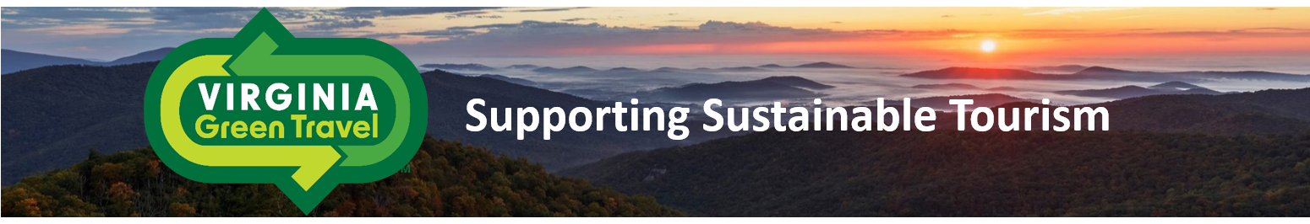

The Virginia Green program strives to **educate** the tourism industry about sustainable practices and innovative products that can significantly reduce the environmental impacts of their operations. Furthermore, Virginia Green strives to **engage** our partners and consumers in a meaningful dialogue that is mutually beneficial. Together, we strive to promote the Virginia Green partners and achieve environmental **results**.

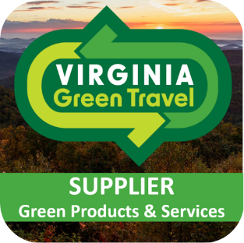

**Virginia Green Suppliers Network**

1800+ tourism businesses have voluntarily certified their environmental commitments and practices and been recognized as certified Virginia Green Partners. Suppliers of green products and services are an important part of our program’s success. Suppliers are working with our certified partners to help them meet the requirements of our program and to continuously improve over time.

**The Virginia Green Suppliers Network is our**

**directory of green products and service providers.**

**How To Apply & How Does the Virginia Green Suppliers Network Work?**

* Fill out the checkbox form below. Essentially, you are just providing a description of your products and services and an explanation as to why they are green.
* We ask that you provide a website / webpages where these product can be found easily.
* We do ask that you sign a general environmental commitment statement affirming that your company is also committed to reducing environmental impacts through recycling, energy and water conservation, etc.
* Once we process your application, we will send you an electronic invoice for the directory listing ($125 for a 2-year listing).
* Then your company will be listed on our on-line directory that we periodically send to our program partners.
* You will receive notices about conferences and workshops.
* We will send you our logo electronically to use and stickers for the program.
* We will announce your company in the next newsletter and on social media.

The Virginia Green program is administered by the non-profit Virginia Green Travel Alliance (VGTA) and works in partnership with the Virginia Tourism Corporation, the Virginia Department of Environmental Quality, Virginia State Parks and the Virginia Restaurant, Lodging & Travel Association.

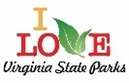

**Joining the Virginia Green Suppliers Network program is easy!**

**Just provide information about your business and “green” product(s), scan the application and return it to** [**VirginiaGreenTA@gmail.com**](mailto:VirginiaGreenTA@gmail.com)**. We will send you an electronic invoice ($125 for a 2-year membership) and then process your listings.**

**Company Information:**

Company: _____________________________________________________________________

Contact Name/Title: ____________________________________________________________

Address: ______________________________________________________________________

City/State/Zip: __________________________________________________________________

Phone: ____________________________Email: _______________________________________

**Statement of Environmental Commitment:** We understand that Virginia Green participants not only want green products and services, but that they also want to do business with companies that share their

environmental commitment. We certify that our organization is recycling and taking other steps to reduce the

environmental impacts of its daily operations.

Signature: ____________________________________________________Date: ________________________

**Information On Each Product/Service**

**1) Name of Product/Service: ____________________________________________**

* Provide link to “green page” of your website (required for listing):
* Briefly explain what kind of product/service it is and how it is relevant to greening of the hospitality industry:

**2) Name of Product/Service: _____________________________________________**

* Provide link to “green page” of your website (required for listing):
* Briefly explain what kind of product/service it is and how it is relevant to greening of the hospitality industry:

3**) Name of Product/Service: ____________________________________________**

* Provide link to “green page” of your website (required for listing):
* Briefly explain what kind of product/service it is and how it is relevant to greening of the hospitality industry:

